- Download a public dataset of online product reviews (for example, from Kaggle or UCI), split it into features and target, and use GridSearchCV to tune the 'max_depth' and 'n_estimators' hyperparameters of a RandomForestClassifier to predict if a review is positive or negative.
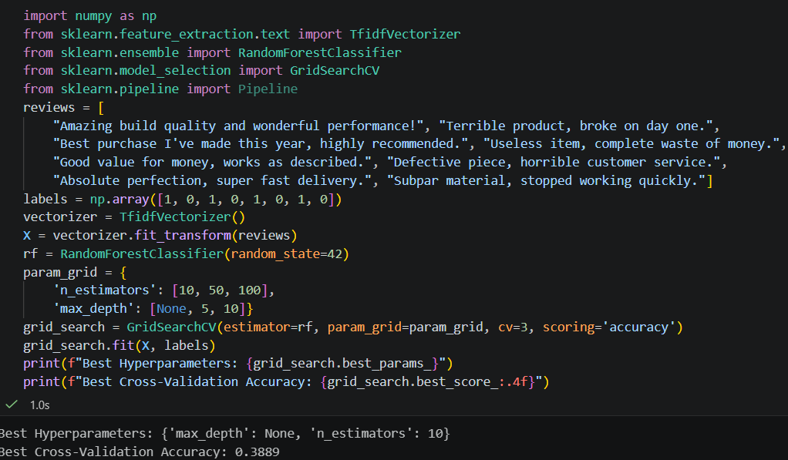

- Use RandomizedSearchCV to tune the 'C' and 'gamma' parameters of an SVM classifier on a dataset of your choice (such as predicting if an Instagram post will get high engagement based on features like caption length, time of posting, and hashtag count). Limit the number of iterations in RandomizedSearchCV to 10 for faster results.
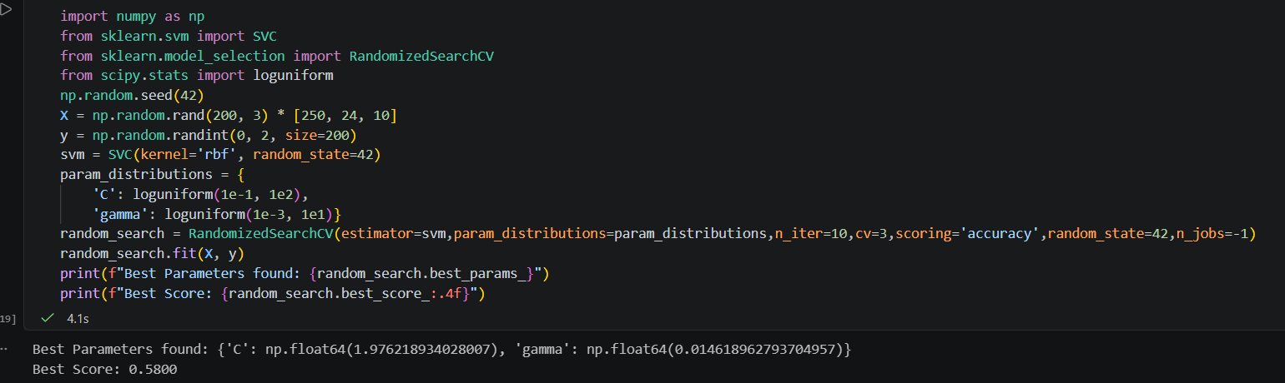

- Pick a dataset with a clear class imbalance (for example, fraud detection or rare event prediction), and apply SMOTE to oversample the minority class before running hyperparameter tuning with GridSearchCV on a RandomForestClassifier. Use the imblearn library’s SMOTE class for oversampling.
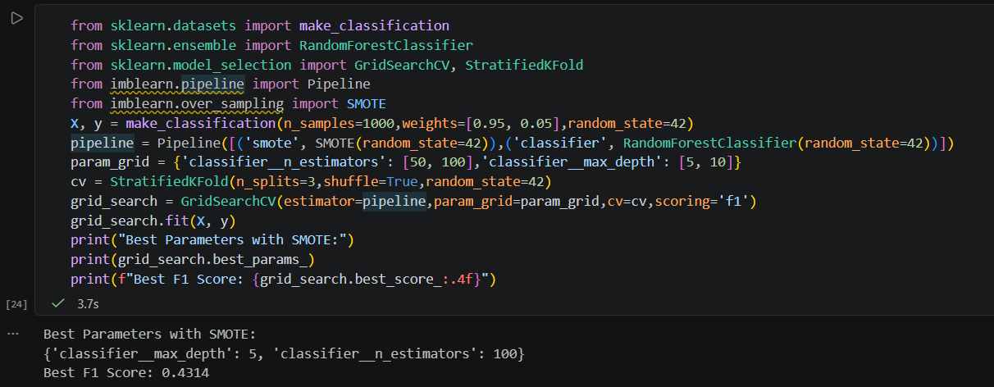

- Modify your hyperparameter tuning process to include class_weight='balanced' in your SVM or RandomForestClassifier and observe how the model’s performance changes on the minority class. Report both accuracy and F1-score before and after using class weights.
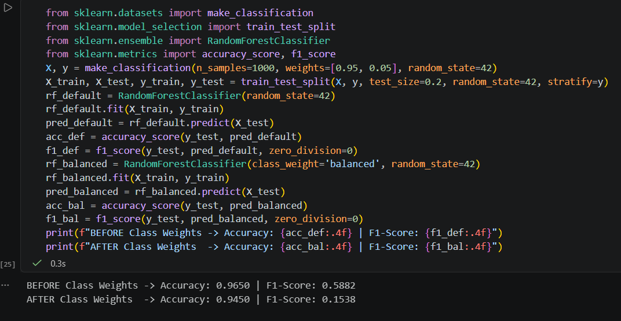

- Use ChatGPT or another AI coding assistant to generate a sample GridSearchCV parameter grid for tuning a RandomForestClassifier on a dataset of your choice, then implement and run the suggested grid in your code. Ask the AI to explain why they chose those specific parameter ranges.
